AI FAQ ASSISTANT
PROJECT DOCUMENTATION

1. INTRODUCTION
Project Title: “AI FAQ Assistant”
Team Members:
- Gopika.L
- Kaviya.M
- Kavipriya.P
- Monika.S
Introduction
AI FAQ Assistant is a system designed to provide quick and relevant answers to frequently asked questions. It helps users find required information without manually searching through a large collection of questions and answers.
The system allows users to register and log in, while authorized users can manage FAQ information. Users can also ask questions through the system and receive appropriate responses based on the available FAQ information.

2. PROJECT OBJECTIVE
The main objective of the AI FAQ Assistant is to provide a simple and efficient platform for handling frequently asked questions.
Objectives:
- To provide quick answers to frequently asked questions.
- To reduce the time required to search for information.
- To maintain FAQ information in an organized manner.
- To allow authorized users to add, update, and delete FAQs.
- To allow users to ask questions through the system.
- To provide relevant responses to user questions.
- To make information easily accessible to users.
3. PROJECT DESCRIPTION
The AI FAQ Assistant is an application designed to manage frequently asked questions and provide answers to users.
The system includes user authentication, FAQ management, and question-answer functionality. Users can create an account and log in to the system. Authorized users can add new FAQs, view existing FAQs, update FAQ details, and delete unwanted FAQs.
The Ask Question feature allows users to enter their questions. The system processes the question and provides an appropriate response based on the available FAQ information.
The backend APIs handle communication between the application and the database.

4. TECHNOLOGIES USED
The following technologies are used for developing the AI FAQ Assistant:
Frontend
- HTML
- CSS
- JavaScript
Backend
- Node.js
- Express.js
Database
- MongoDB
API Testing
- Thunder Client
- Visual Studio Code
Authentication
- JWT Authentication
These technologies are used to develop the application, manage FAQ data, provide backend APIs, and test the system functionality.

5. FEATURES OF AI FAQ ASSISTANT
The AI FAQ Assistant provides several features for managing and accessing frequently asked questions.
Main Features:
- User Registration – Allows new users to create an account.
- User Login – Allows registered users to securely access the system.
- Add FAQ – Allows authorized users to add new questions and answers.
- View FAQs – Allows users to retrieve available FAQ information.
- View FAQ by ID – Allows a specific FAQ to be retrieved using its unique ID.
- Update FAQ – Allows existing FAQ information to be modified.
- Delete FAQ – Allows unwanted FAQs to be removed.
- Ask Question – Allows users to enter questions and receive relevant answers.
- FAQ Management – Provides organized management of question-and-answer information.

6. SYSTEM ARCHITECTURE
The AI FAQ Assistant follows a basic client-server architecture.
Working Flow:
User → Frontend → Backend API → Database → Backend API → User
Explanation:
- The user interacts with the application through the frontend.
- The frontend sends the user's request to the backend API.
- The backend processes the request.
- The backend communicates with the MongoDB database when required.
- The database stores or retrieves the required information.
- The backend sends the result back to the frontend.
- The result is displayed to the user.

Main Components:
Frontend:
Provides the interface through which users interact with the application.
Backend:
Processes user requests and provides API services.
Database:
Stores user and FAQ information.
FAQ Module:
Manages questions and answers.
AI Question Module:
Processes user questions and provides relevant responses.

7. DATABASE DESIGN
The database is used to store and manage the information required by the AI FAQ Assistant.
User Collection
The user information includes:
- User ID
- Name
- Email
- Password
FAQ Collection
The FAQ information includes:
- FAQ ID
- Question
- Answer
The database allows the system to store, retrieve, update, and delete FAQ information.
The stored FAQ records are used when processing questions submitted by users.

8. USER REGISTRATION API
The Register API allows a new user to create an account in the AI FAQ Assistant system.
Functionality:
- The user provides details such as name, email, and password.
- The request is sent to the backend server.
- The system processes the registration information.
- The user information is stored in the database.
- A successful registration response is returned.
Purpose:
This API is used to create a new user account in the system.
Screenshot:
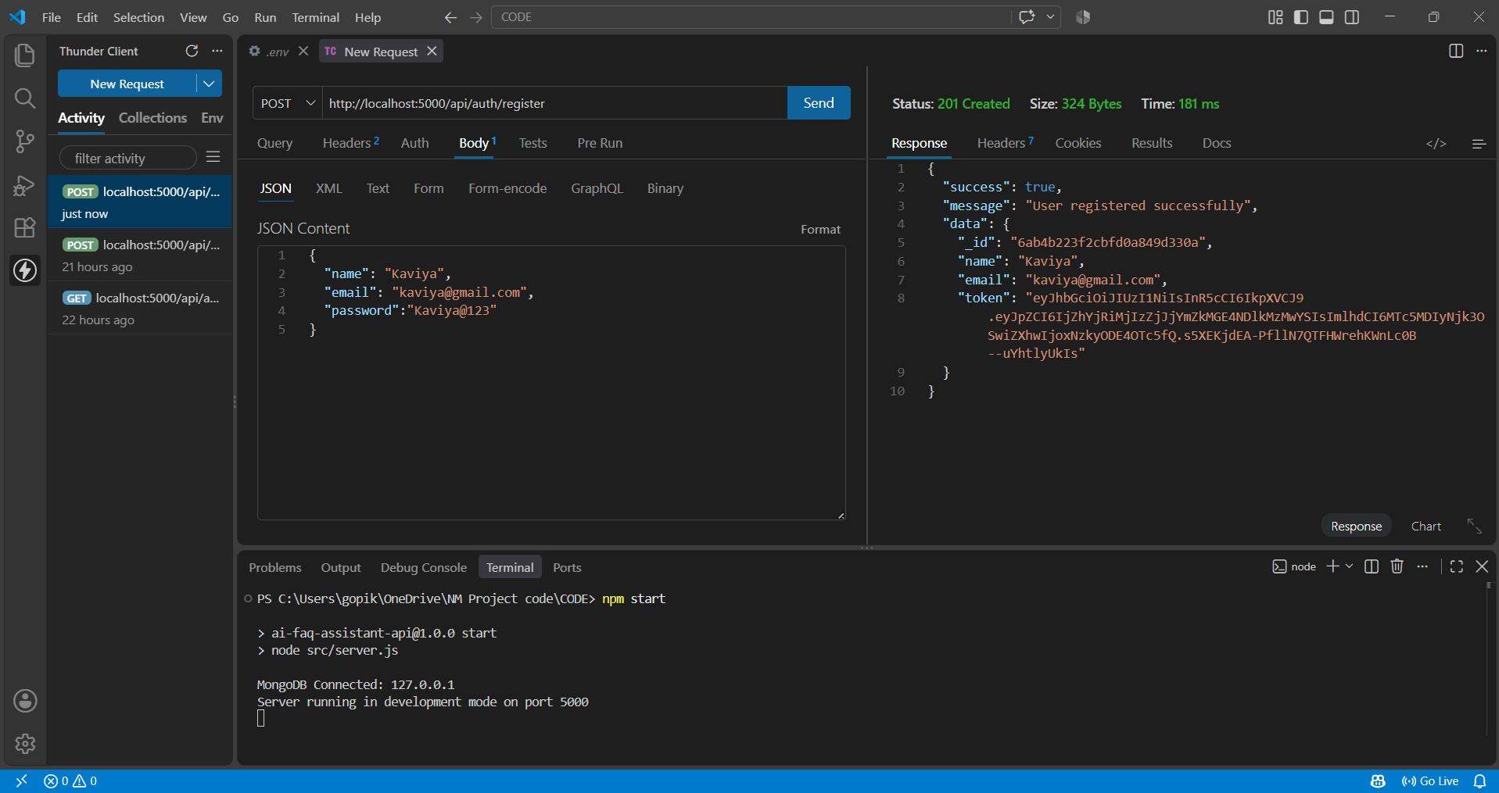

9. USER LOGIN API
The Login API allows an existing user to log in to the AI FAQ Assistant system.
Functionality:
- The user provides their email and password.
- The request is sent to the backend server.
- The system verifies the provided credentials.
- If the credentials are valid, the user is allowed to access the system.
- The system returns a successful login response along with authentication information.

Purpose:
This API is used to authenticate registered users.
Screenshot:
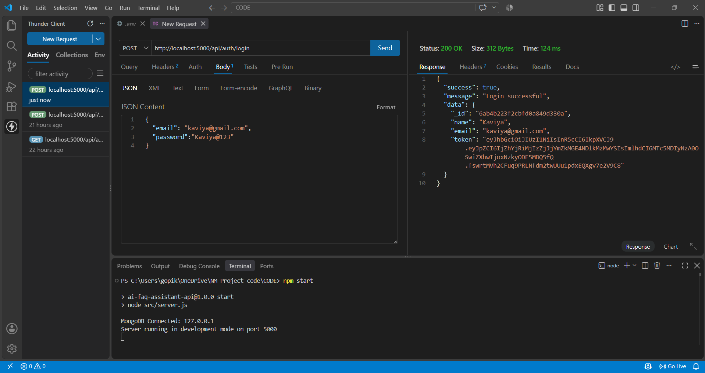

10. PROFILE API
The Profile API allows a logged-in user to view their profile information in the AI FAQ Assistant system.
Functionality:
- The user sends a request to the Profile API after successful login.
- The system verifies the user's authentication information.
- The backend retrieves the user's profile details from the database.
- The profile information is returned in the API response.
- The user can view their personal information through the profile section.
Purpose:
This API is used to retrieve and display the profile information of the logged-in user.

Screenshot:
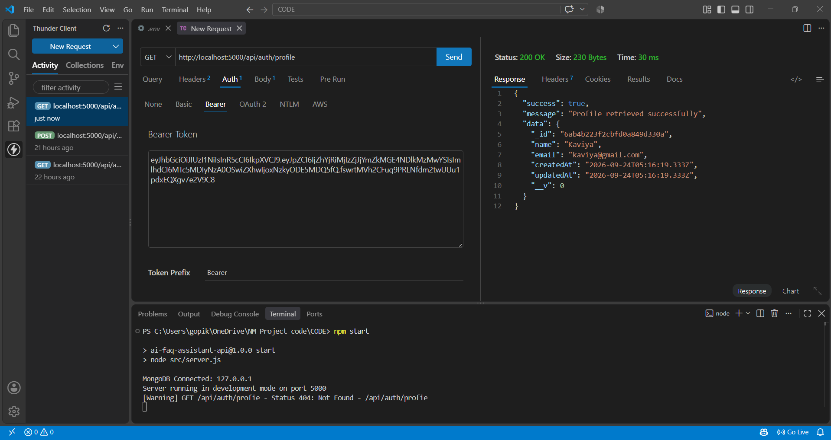

11. GET FAQs API
The Get FAQs API retrieves the available FAQ records from the system.
Functionality:
- The request is sent to the backend server.
- The system retrieves the FAQ records from the database.
- The available questions and answers are returned in the response.
- Users can view the available FAQ information.
Purpose:
This API is used to retrieve the FAQ collection from the database.

Screenshot:
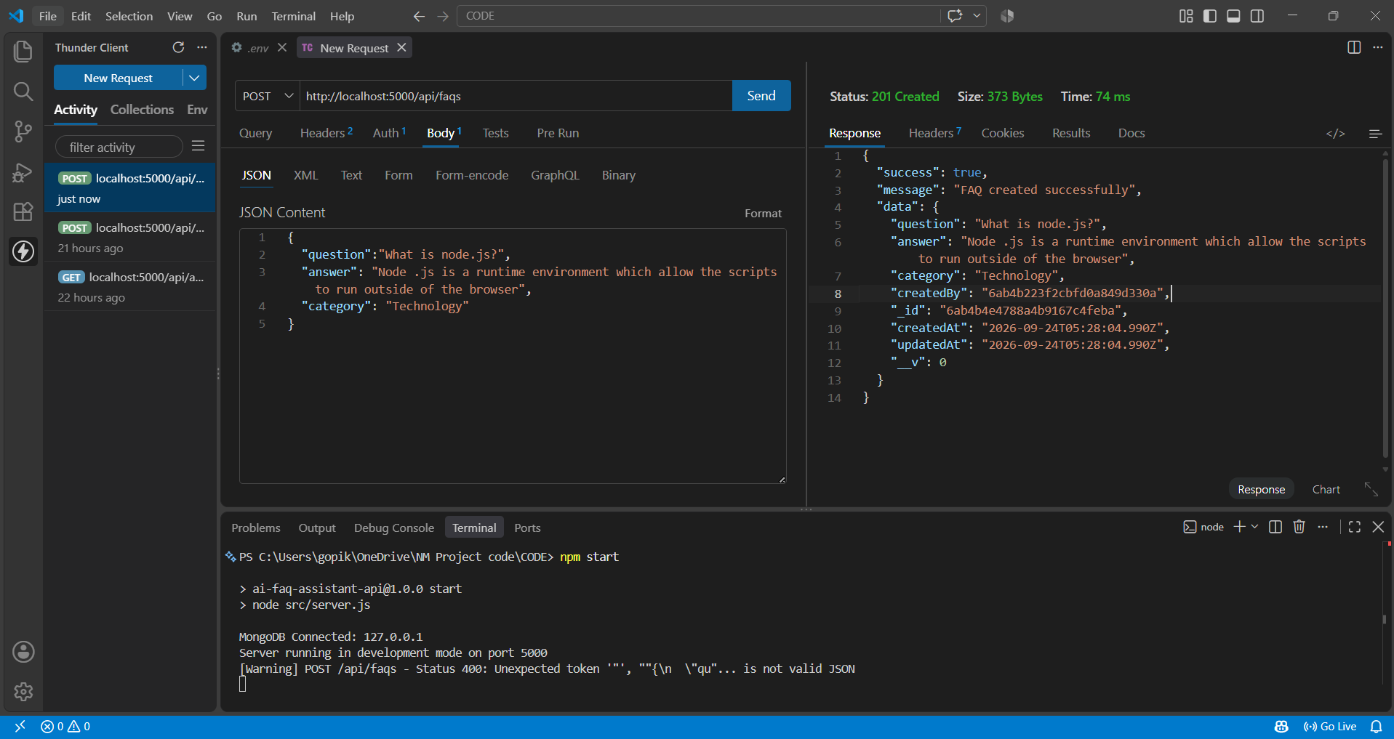

12. UPDATE / DELETE FAQ APIs
A. UPDATE FAQ API
The Update FAQ API allows an authorized user to modify an existing FAQ.
Functionality:
- The FAQ is identified using its unique FAQ ID.
- The user provides the updated FAQ information.
- The backend processes the update request.
- The updated information is saved in the database.
- The updated FAQ details are returned in the response.
Purpose:
This API is used to modify existing FAQ information.

Screenshot:
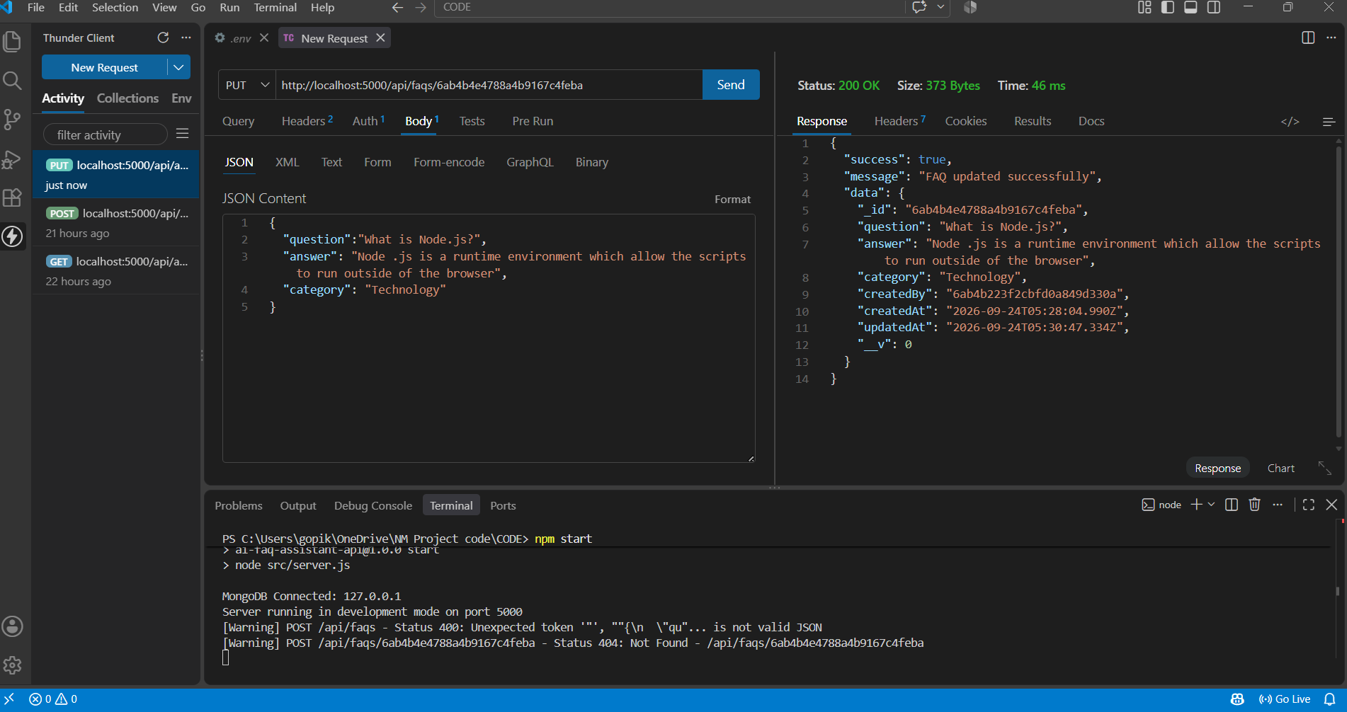
B. DELETE FAQ API
The Delete FAQ API allows an authorized user to remove an existing FAQ.
Functionality:
- The FAQ is identified using its unique FAQ ID.
- The backend searches for the selected FAQ.
- The selected FAQ is removed from the database.
- A confirmation response is returned after successful deletion.
Purpose:
This API is used to remove unwanted or outdated FAQs from the system.
Screenshot:
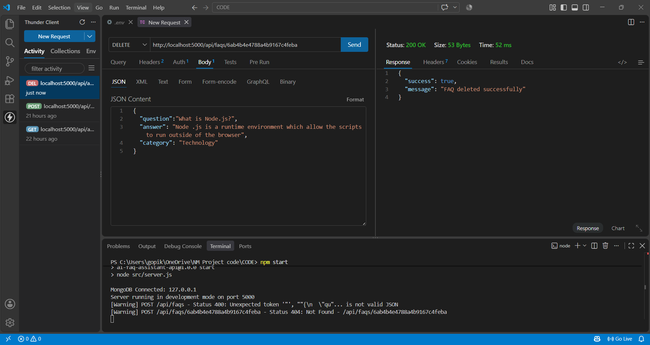

13. ASK QUESTION / GENERATE FAQs API
The Ask Question API is the main feature of the AI FAQ Assistant.
Functionality:
- The user enters a question.
- The question is sent to the backend API.
- The system processes the user's question.
- The system identifies relevant FAQ information.
- An appropriate response is generated or retrieved.
- The answer is returned to the user in the API response.
Purpose:
This API allows users to interact with the AI FAQ Assistant and obtain answers to their questions.
Example:
User Question:
“What are the working hours?”
Assistant Response:
“The working hours are from 9:00 AM to 5:00 PM.”
Screenshot:
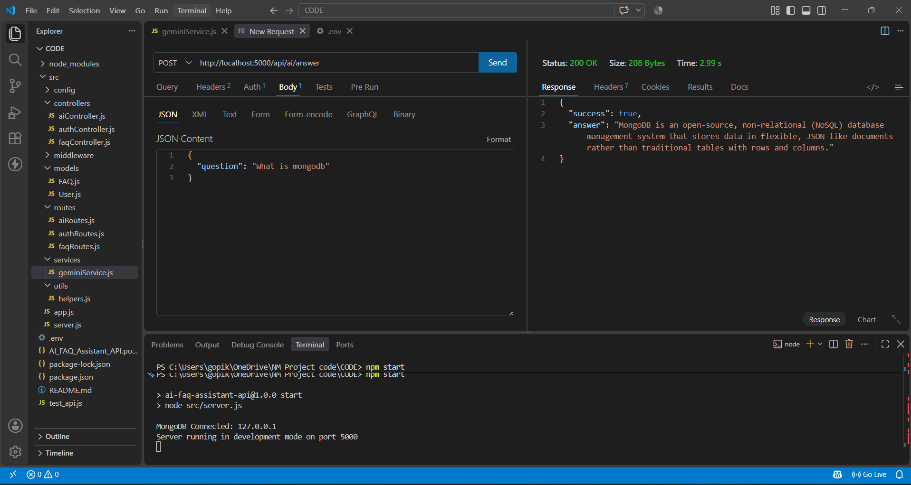

(b)GENERATE FAQs API
The Generate FAQs API is used to generate frequently asked questions based on the information provided to the system.
Functionality:
- The user provides the required information or content.
- The request is sent to the backend server.
- The system processes the provided information.
- The AI processes the content and generates relevant frequently asked questions.
- The generated FAQs are returned in the API response.
Purpose:
This API is used to automatically generate relevant FAQ questions from the provided information.
Screenshot:
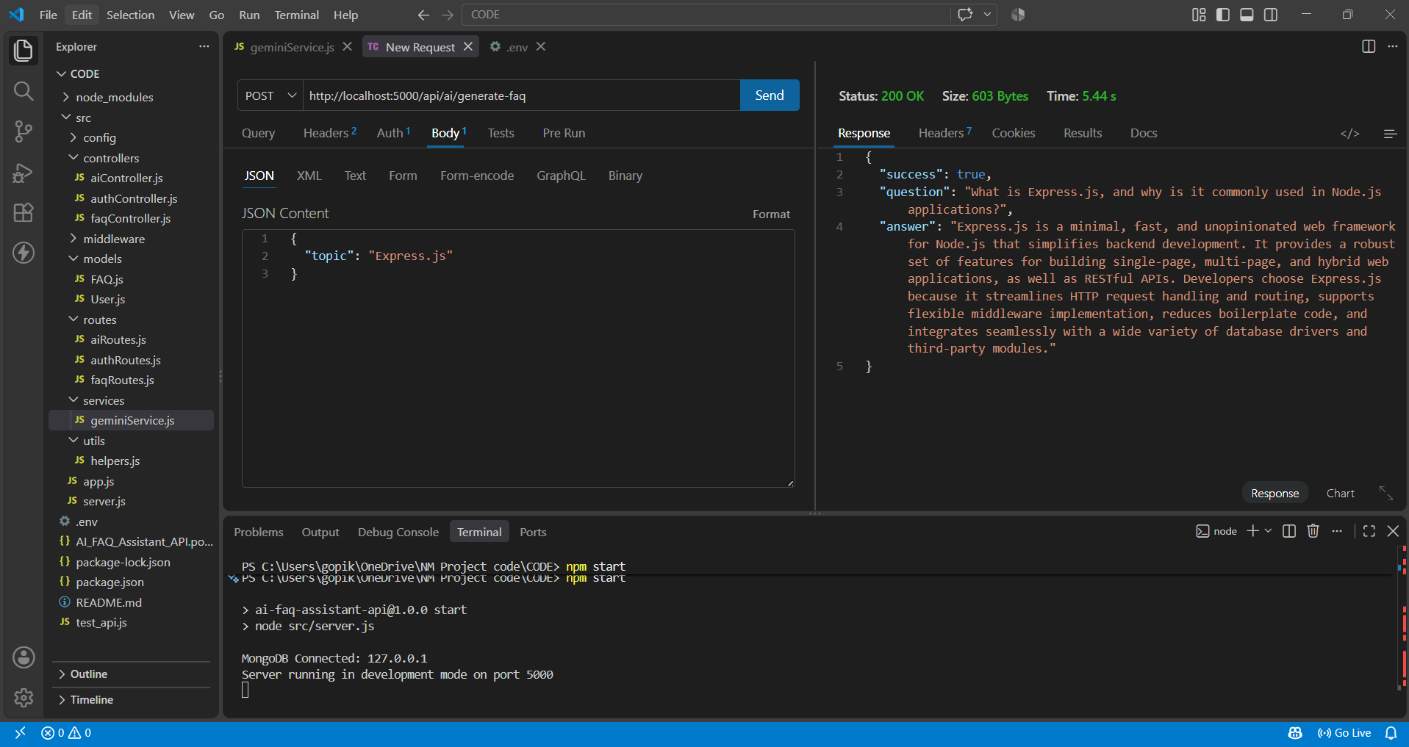

14. CONCLUSION
The AI FAQ Assistant provides a simple and efficient solution for managing frequently asked questions and providing relevant answers to users.
The system includes user registration and login functionality along with FAQ management operations such as adding, retrieving, updating, and deleting FAQs. The Ask Question feature allows users to submit questions and receive appropriate responses.
The backend APIs provide communication between the application and database, while MongoDB is used to store the required information. Thunder Client can be used to test the API operations during development.
Overall, the AI FAQ Assistant helps organize FAQ information and makes accessing answers faster and easier for users.

